Mother Knows Breast:
Helping Moms Gain Confidence in their Milk Production

Presented by: Cathy Carothers, IBCLC, FILCA
Every Mother, Inc.
cathy@everymother.org

Learning Objectives:
- Identify common beliefs about milk production among mothers.
- Name key factors involved in establishing a healthy milk production.
- Identify ways to counsel mothers about normal infant behaviors.
- Identify ways to talk to new mothers about their milk production.

Beliefs about Milk Production
- Concern about milk production is the #1 reason women give for beginning formula, and for weaning at every critical weaning period.
(McLeod 2002; Lewallen 2006)
- Over half of women believe they are not making enough milk. And the issue is not constrained to the U.S. It is a global concern.
- Over half of breastfeeding women say they are discharged from the hospital without professional assistance. (Lewallen 2006)
- Myths about milk production abound

Why Women Doubt Their Milk Production
- You can’t see what the baby is taking
- Hospital practices
- Baby is fussy
- Baby does not sleep well at night
- Mom used a breast pump and got little milk
- Mother is separated from her baby
- Mother really DOES have physiological issues impacting her production

Teaching Mothers How Their Breasts Make Milk
- Formula for Healthy Milk Production [West & Marasco 2009]
- Breast changes during pregnancy
- Milk factories
- Milk-making cells (alveoli) develop during pregnancy
- Alveoli bunch into 7-10 clusters or lobes
- Muscles (myoepithelial cells) tighten to release milk
- Milk highway system – transports milk through the breast
- Hormone receptors
- Milk removal (especially EARLY milk removal) drives the system
- The opposite (full breasts) slows things down!
- FIL levels rise
- Internal pressure reduces blood flow
- Milk cells are compressed
- Breast tissue begins involution
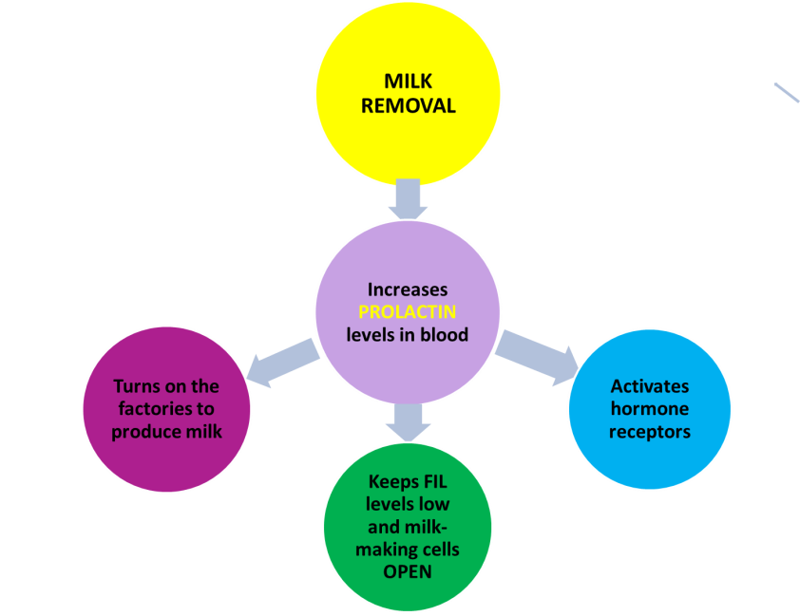

Tools that Build Confidence
- Simple language
- Measuring devices
- “Pour Offs”
- Everyday gadgets and analogies
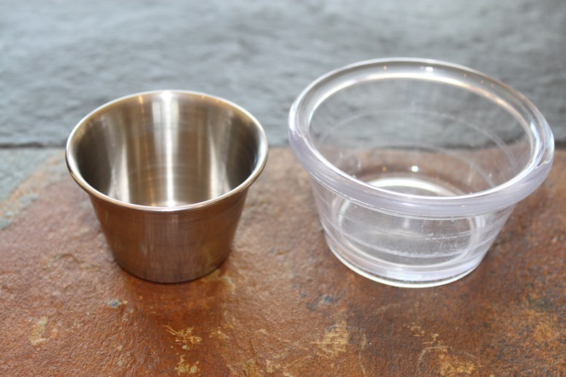




Formula Changes Things!
- Stomach is at greater risk of allergy sensitization from non-human milks.
- Significantly alters gut flora.
- B-Lacta-albumin is an environmental trigger for allergies and diabetes. [Cantani 2003]

Understanding Normal Infant Behaviors
Secrets of Baby Behavior – www.secretsofbabybehavior.com
- Infant states
- Crying
- Irritability
- Quiet alert
- Drowsy
- Active sleep
- Deep sleep
- Why babies cry and fuss
- Common reasons why infants cry besides hunger
- Soothing techniques
- Why babies sleep
- Normal infant sleep cycle
- What is happening in light vs. deep sleep

Counseling Mothers who Want to Supplement
- Ask the right questions
- Never make assumptions; look for hidden motives
- Examine the evidence
- Use critical thinking to draw conclusions
- If in doubt, REFER!

Moms Who Just Want to Pump
- Reasons mothers may want to pump
- Impact of just pumping on a mother’s milk production
- Counseling mothers who just want to pump

Talking with New Moms
- During early weeks many mothers report difficulty following instructions, remembering facts, and keeping track of time – all governed by left brain. [Eidelman 1993]
- Mothers have enhanced RIGHT brain capacity – perhaps to connect with baby [Schore 2001]
- Tune in to the mother’s EMOTIONS
- Teach her why her baby fusses and cries.
- Affirm! Affirm! Affirm!
- Mothers may equate feelings about their milk production with feelings about their life. [Chin 2009]
- Show her what she is doing right.
- Show her how her baby loves her.
- Power of Praise!

Bibliography
Academy of Breastfeeding Medicine . ABM Protocol #19: Breastfeeding Promotion in the Prenatal Setting, 2009. Available online at: http://www.bfmed.org/Media/Files/Protocols/Protocol%2019%20-%20Breastfeeding%20Promotion%20in%20the%20Prenatal%20Setting.pdf

American Academy of Pediatrics, Section on Breastfeeding. Policy Statement: Breastfeeding and the use of human milk. Pediatrics.2012;115(2):496. Available at: http://pediatrics.aappublications.org/content/129/3/e827.full

Arora, S. et al. Major factors influencing breastfeeding rates: mother’s perception of father’s attitude and milk supply. Pediatrics.2000;106(5):e67.

Barron, S. et al. Factors influencing duration of breast feeding among low-income women. J Amer Dietetic Assoc.1988; 88:15557-1561.

Blyth R, Creedy D, Dennis C, et al. Effect of maternal confidence on breastfeeding duration: An application of breastfeeding self-efficacy theory. Birth.2002;29:278-284.

Bolton TA, Chow T, Benton PA & Olson BH. Characteristics associated with longer breastfeeding duration: an analysis of a peer counseling support program. J Hum Lact. 2009;25:18-27.

Bourgoin G, et al. Factors influencing breastfeeding in the Sudbury Region. Can J Pub Hlth.1997;88:238-241.

Businco L, Bruno G, Giampietro PG. Prevention and management of food allergy. Acta Paediatr Suppl (430)
1999; 88:104-109

Cantani W & Micera M. Neonatal cow milk sensitivity in 143 case reports: role of early exposure to cow’s milk formula. Eur Rev Med Phamacol Sci.2005;9:227-230.

Caulfield, et al. WIC-based interventions to promote breastfeeding among African-American women in Baltimore: effects on breastfeeding initiation and continuation. J Hum Lact. 1998;14(1):15-22.

Chin N & Solomonik A. Inadequate: A Metaphor for the Lives of Low-Income Women? Breastfeeding Med. 2009;4(1): 41-43.

Cregan MD, Mitoulas LR, Hartmann PE. Milk prolactin, feed volume and duration between feeds in women breastfeeding their full-term infants over a 24 h period. Exp Physiol. 2002;87:207-214.

Czank C, Henderson JJ, Kent JC, Tat LAI c & Hartmann PE. Hormonal control of the lactation cycle. In T.W. Hale & P.E. Hartmann (Eds.), Hale & Hartmann’s Textbook of Human Lactation (pp. 89-111). Amarillo, TX: Hale Publishing, 2007.

Daily SE, Kent JC, Owens RA & Hartmann PE. Frequency and degree of milk removal and the short-term control of human synthesis. Exper Phys. 1996;81(5), 861-875.

Daly, S, & Hartmann, P. Infant demand and milk production in lactating women, Part I. J Hum Lact. 1995;11(1), 21-26.

DaMota K et al. Maternal request for in-hospital supplementation of healthy breastfed Infants among
low-income women. J Hum Lact. 2012;28(4):476-482.

Dennis, C. Theoretical underpinning of breastfeeding confidence: a self-efficacy framework. J Hum Lact, 15(3):195-201.

Dewey KG, et al. Risk factors for suboptimal infant breastfeeding behavior, delayed onset of lactation, and excess neonatal weight loss. Pediatrics. 2003;112:607-619.

DiGirolamo, et al. Maternity care practices: implications for breastfeeding. Birth. 2001;28(2):94-100.

Ertem, J, et al. The timing and predictors of the early termination of breastfeeding. Pediatrics. 2001;107:543-548.

Ekstrom A, Widfstrom AM & Nissen E. Duration of breastfeeding in Swedish primiparous and multiparous women. J Hum Lact. 2003;19:172-178.

Ekstrom A & Nissen E. A mother’s feelings for her infant are strengthened by exclusive breastfeeding counseling and continuity of care. Pediatrics. 2003;118(2):e309-e314.

Freeman ME, Kanyicska B, Lerant A & Nagy G. Prolactin: structure, function, and regulation of secretion. Phys Rev. 2000; 80(4), 1523-1631.

Gagnon AJ, Leduc G, Waghorn K, Yang H & Platt RW. In-hospital formula supplementation of healthy breastfeeding newborns. J Hum Lact. 2005; 21:397-405

Geddes DT. Inside the lactating breast: the latest anatomy research. J Midwifery & Wom Hlth. 2007;52(6), 556-563.

Grummer-Strawn L, Scanlon K & Fein S. (2008). Infant feeding and feeding transitions during the first year of life. Pediatrics, 122:S36-S42.

Guttmann, N. & Zimmerman, D. Low-income mothers’ views on breastfeeding. Soc Sci and Med. 2000;50:1457-1473.

Hornell A, Hofvander Y & Kylberg E. Solids and formula: association with pattern and duration of breastfeeding. Pediatrics. 2001;107(3). Retrieved from http://pediatrics.aappublications.org/content/107/3/e38.full. Accessed 9-4-14.

Humenick, et al. Breastfeeding and health professional encouragement. J Hum Lact. 1998;14(4):305-310.

Hurst N et al. Skin-to-skin holding in the neonatal intensive care unit influences maternal milk volumes. J Perinatology. 1997;17:213-217
Izatt, S. Breastfeeding counseling by health care providers. J Hum Lact. 1997;13(2):109-113.

Kent JC et al. Volume and frequency of breastfeeding and fat content of breast milk throughout the day. Pediatrics. 2006;117:387-395.

Kent JC, Ramsay DT, Doherty D, Larson M & Hartmann PE. Response of breasts to different stimulation patterns of an electric breast pump. J Hum Lact. 2002;19(2):179-187,

Kent J. How breastfeeding works. J Midwifery Wom Hlth. 2007; 52(6):564-570.

Kent JC, Ramsay DT, Doherty D, Larson M & Hartmann PE. Response of breasts to different stimulation patterns of an electric breast pump. J Hum Lact. 2002;19(2):179-187.

Kuan, L., et al. Health system factors contributing to breastfeeding success. Pediatrics. 1999;104(3): e28.

Lewallen LP, et al. Breastfeeding support and early cessation. JOGNN. 2006;35(2): 166-172.

Lindberg, C, et al. The effect of early post-partum mother-infant contact and breast-feeding promotion on the incidence and continuation of breast-feeding. Int. J Nursing Studies. 1990;27(3):179-186.

McLeod D, Pullon S, & Crookston T. Factors influencing continuation of breastfeeding in a cohort of women. J Hum Lact. 2002;18(4), 335-343.

McLorg, P, & Bryant, C. Influence of social network members and health care professionals on infant feeding practices of economically disadvantaged mothers. Med Anthr. 1989;10:265-278.

Medela. www.medela.com

Mohrbacher N. The magic number and long-term milk production. Clinical Lactation Journal. 2011; 2(1):15-18.

Morhbacher N. Breastfeeding Answers Made Simple: A Guide for Helping Mothers, Amarillo, TX: Hale Publishing, 2010.

Mohrbacher N & Kendall-Tackett K. Breastfeeding Made Simple: Seven Natural Laws for Nursing Mothers. Oakland, CA: New Harbinger Publication, 2005.

Nommsen-River L et al. Delayed onset of lactogenesis among first-time mothers is related to maternal obesity and factors associated with ineffective breastfeeding. Am J Clin Nutr. 2010.

Otoo G, et al. HIV-negative status is associated with very early onset of lactation among Ghanian women. J Hum Lact. 2009;26(2):107-117.

Piper S & Parks L. Use of an intensity ratio to describe breastfeeding exclusivity in a national sample. J Hum Lact. 2011;17:227-232.

Ramsay, DT, et al. Anatomy of the lactating breast redefined with ultrasound imaging. Journal of Anatomy #206, 2005.

Rasmussen, KM, et al. Prepregnant overweight and obesity diminish the prolactin response to suckling in the first week postpartum. Pediatrics. 2004;113e465-3471.

Perez-Escamilla, R, et al. Infant feeding policies in maternity wards and their effect on breast-feeding success: an analytical overview. Am J Pub Hlth. 1994;84(1):89-97.

Schanler, R, et al. Pediatricians’ practices and attitudes regarding breastfeeding promotion. Pediatrics. 1999; 103(3):e35.

Schmied, V. Connection and pleasure, disruption and distress: women’s experience. J Hum Lact. 1999; 15(4):325-334.

Schore A. The effect of early relationship trauma on right brain development, affect regulation, and infant mental health. Infant Mental Health Journal. 2001;22:201-269.
Tender J et al. Reasons for In-Hospital Formula Supplementation of Breastfed Infants From Low-Income Families. J Hum Lact. 2009;25(1):11-17.

Thorley V. Accounts of infant-feeding advice received by mothers: Queensland, Australia, 1945-1965. Nursing Reports. 2012;2e12:71-79.

United States Department of Agriculture. WIC Infant Feeding Practices Study: Summary of Findings. United States Department of Agriculture, Food & Nutrition Service. November 1997.
http://www.fns.usda.gov/oane/MENU/Published/WIC/files/infant/ifps.htm

University of California, Davis. Secrets of Baby Behavior. Davis, CA: University of California Human Lactation Center. Website: http://lactation.ucdavis.edu/products/babybehaviorproducts.html.

Walker, Marsha. Breastfeeding Management for the Clinician. Boston: Jones & Bartlett Publishers, 2006.

West D & Marasco L. The Breastfeeding Mother’s Guide to Making More Milk. Random House, 2009.

Wolf, J. Low breastfeeding rates and public health in the United States. Am J of Hlth Prom. 2003;93(12):2000-2010.

Wolf, J. Let us have more mother-fed babies: early twentieth-century breastfeeding campaigns. J Hum Lact. 1999;15:101-105

Wright, A., et al. Changing hospital practices to increase the duration of breastfeeding. Pediatrics. 1996; 97:669-675.

